**CLIENT REGISTRATION**

**HOME PAGE**

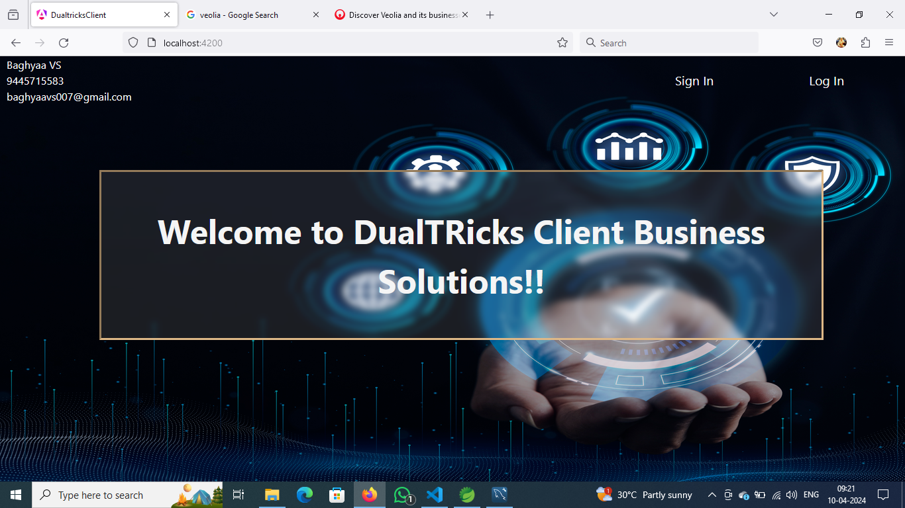

**SIGNIN PAGE**

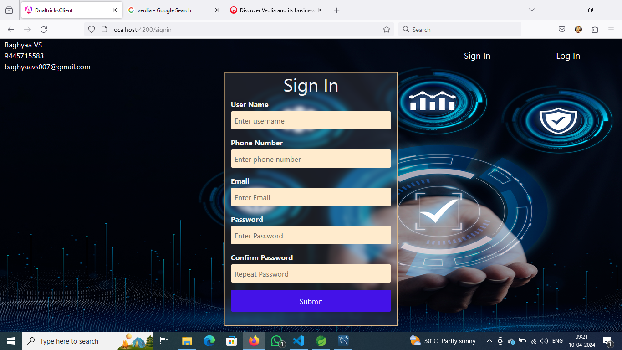

**LOGIN PAGE**

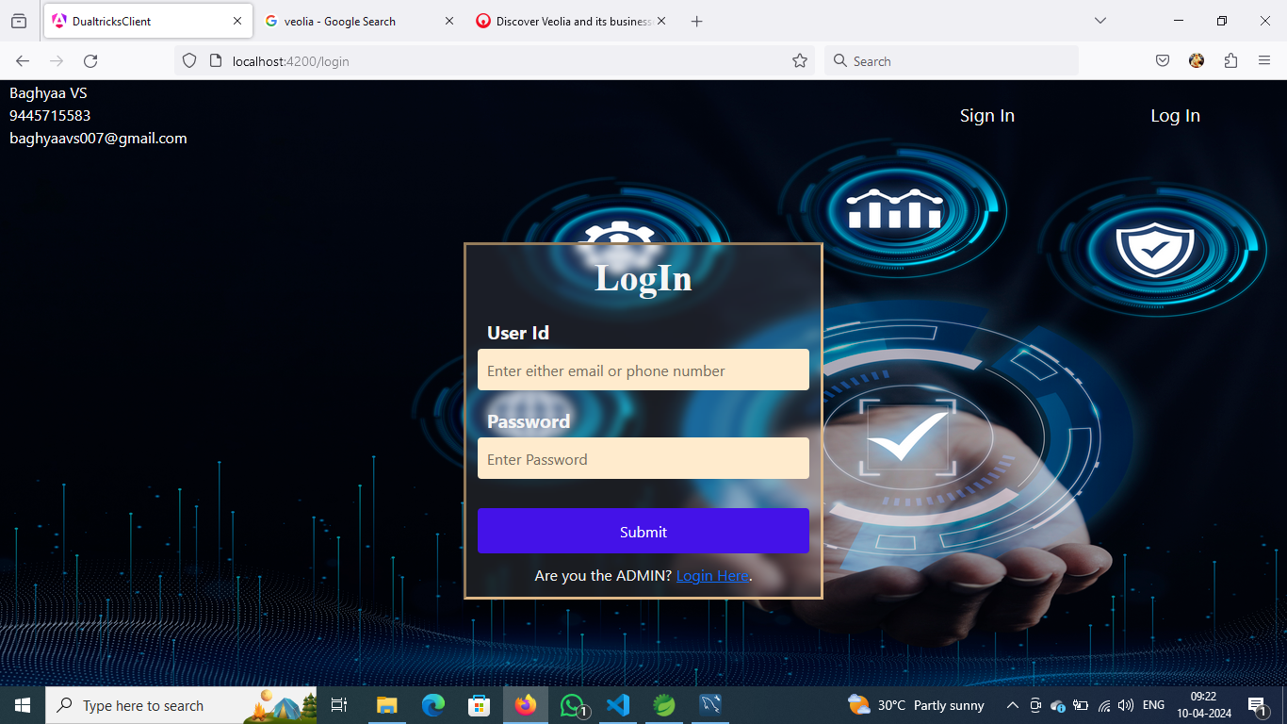

**CLIENT REGISTRATION PAGE**

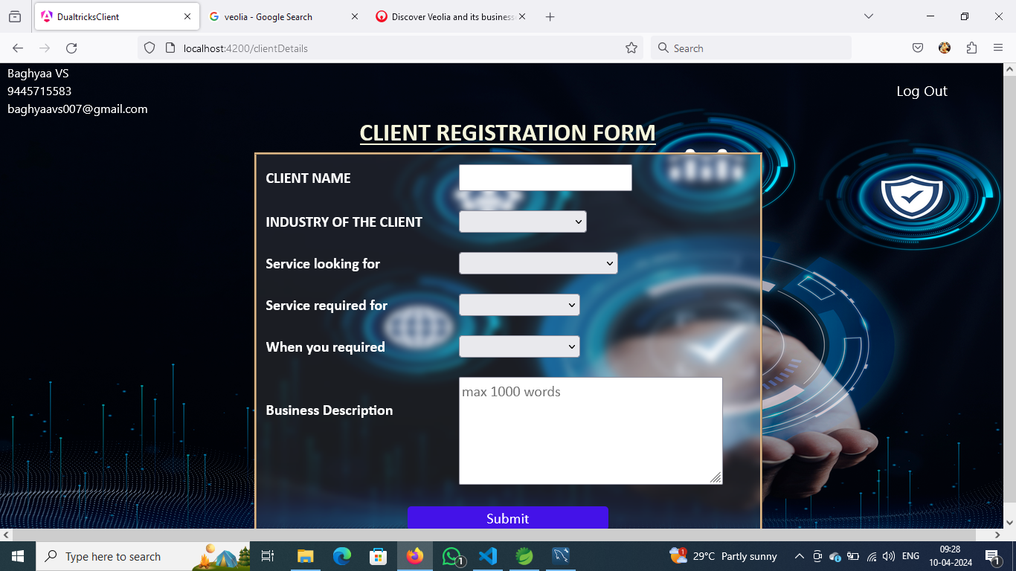

**THANK YOU PAGE**

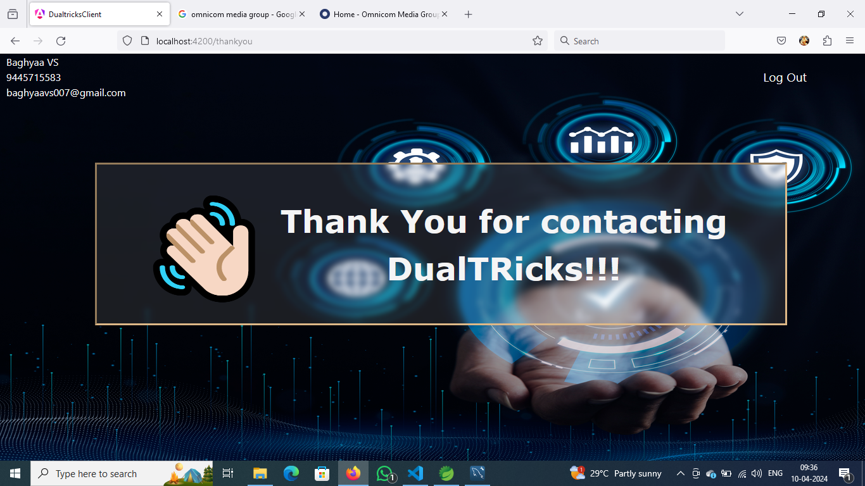

**ADMIN LOGIN PAGE**

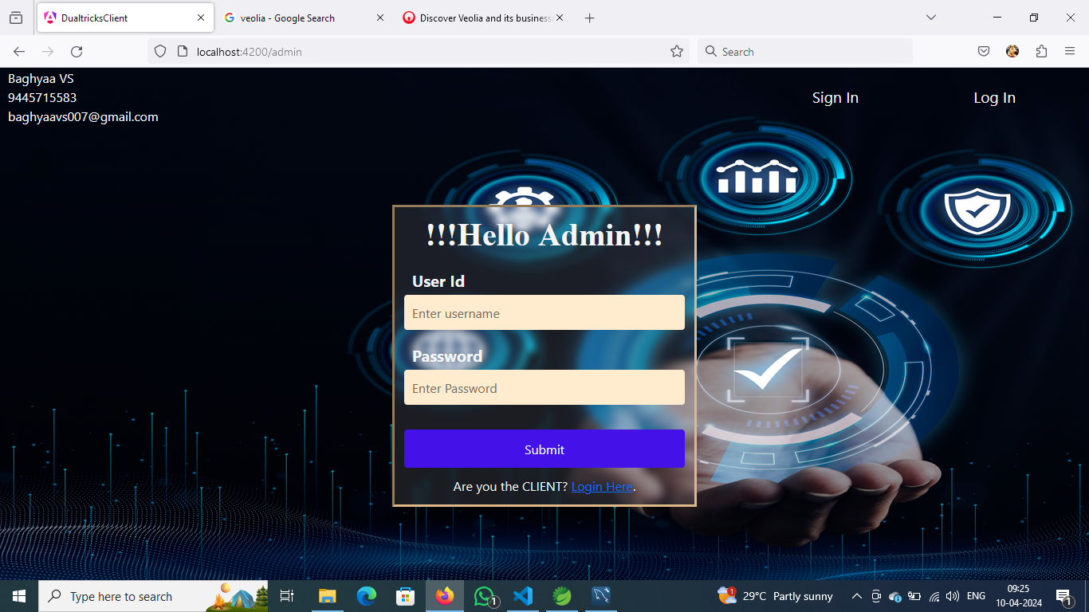

**CLIENT DETAILS FOR ADMIN**

